**Assignment 10 – Kubernetes Test Questions 2**

Name: Mohamad Haffiz Bin Mohd Hissham

**Questions:**

1.

Create a static pod named **'nginx-pod' on node01** with the **NGINX image**. Ensure that the **pod automatically restarts** in case of any failure. Describe the steps you would take to achieve this, including the YAML configuration and the directory where you would place the configuration file.

2."Design a Kubernetes **pod named 'pod-multi'** consisting **of two containers**. Container **1 should be named 'nginx-container'** and use the **NGINX image**, while **Container 2** should be named **'busybox-container'** and use the **BusyBox image with a command to sleep for 4800 seconds.** Provide the YAML configuration for this pod setup, ensuring that both containers are correctly defined. Additionally, discuss any considerations or potential issues when deploying pods with multiple containers."

**Question 1:**

1. Connect to **node01**. Run this command, **ssh node01**
   1. 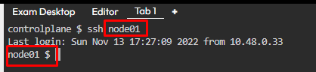
2. Find the path of kubelet config, **ps aux | grep kubelet**
   1. 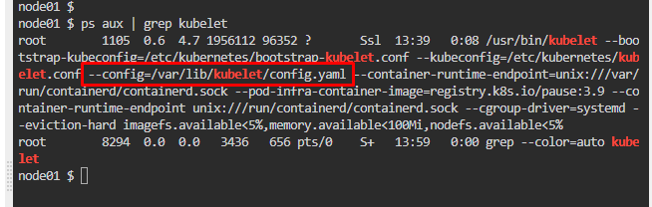
3. Find the path of the **pod** **manifest folder** from kubelet config file, **cat /var/lib/kubelet/config.yaml | grep static**
   1. 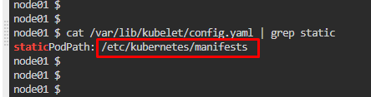
4. Change the directory, go to the pod manifest folder. **cd /etc/kubernetes/manifests**
   1. 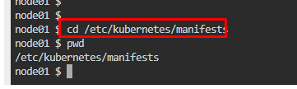
5. Create a config file for the manifest folder, **nano nginx-pod.yml**
6. Write a YAML script following question’s requirements
   1. A screenshot of a computer

      Description automatically generated
7. Exit ssh connection, check pod status. **Kubectl get pods**
   1. A screenshot of a computer

      Description automatically generated
8. Need to fix container auto restart policy. Add **restartPolicy: Always** in the YAML code.
   1. eg, connect to node01 again
   2. 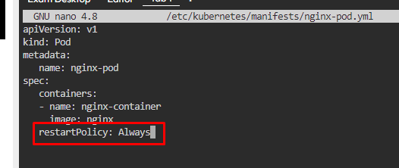

**Question 2:**

1. Run a **dry-run** command to generate a basic YAML file, **kubectl run pod-multi --image=nginx -o yaml --dry-run=client > pod-multi.yml**
   1. 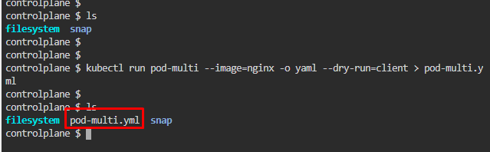
2. Edit **pod-multi.yml** file following question’s requirements. **nano pod-multi.yml**
   1. A screenshot of a computer

      Description automatically generated
3. Apply the YAML config to create containers. **kubectl apply -f pod-multi.yml** | Check pods created
   1. A screen shot of a computer

      Description automatically generated
   2. A screenshot of a computer

      Description automatically generated